**ERRORES CON ORACLE**

**me sale este error al querer instalar el paquete cx-Oracle:**

C:\Users\Diego Torres\OneDrive\Python\My-Python> pip install cx-Oracle Collecting cx-Oracle Using cached cx_Oracle-8.3.0.tar.gz (363 kB) Installing build dependencies ... done Getting requirements to build wheel ... done Preparing metadata (pyproject.toml) ... done Building wheels for collected packages: cx-Oracle Building wheel for cx-Oracle (pyproject.toml) ... error error: subprocess-exited-with-error × Building wheel for cx-Oracle (pyproject.toml) did not run successfully. │ exit code: 1 ╰─> [8 lines of output] <string>:6: DeprecationWarning: pkg_resources is deprecated as an API. See https://setuptools.pypa.io/en/latest/pkg_resources.html C:\Users\Diego Torres\AppData\Local\Temp\pip-build-env-v8y6wk2m\overlay\Lib\site-packages\setuptools\config\expand.py:134: SetuptoolsWarning: File 'C:\\Users\\Diego Torres\\AppData\\Local\\Temp\\pip-install-l_frj3rx\\cx-oracle_a641bcdce6a3483780912dc7220f943d\\README.md' cannot be found return '\n'.join( running bdist_wheel running build running build_ext building 'cx_Oracle' extension error: **Microsoft Visual C++ 14.0 or greater is required. Get it with "Microsoft C++ Build Tools": https://visualstudio.microsoft.com/visual-cpp-build-tools/** [end of output]

note: This error originates from a subprocess, and is likely not a problem with pip. **ERROR: Failed building wheel for cx-Oracle Failed to build cx-Oracle ERROR: Could not build wheels for cx-Oracle, which is required to install pyproject.toml-based projects**

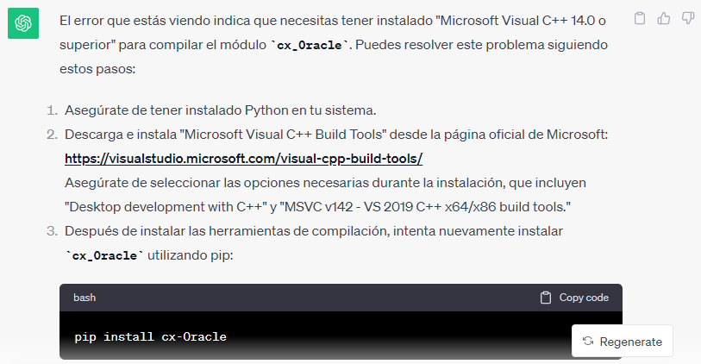

Solución 2:

Python 3.6 and higher are supported by cx_Oracle 8.3. If you use Python 2, then the older cx_Oracle 7.3 will install.

* Install cx_Oracle from [PyPI](https://pypi.org/project/cx-Oracle/) with:
* python -m pip install cx_Oracle --upgrade

Note: if a binary wheel package is not available for your platform, the source package will be downloaded instead. This will be compiled and the resulting binary installed.

The --user option may be useful, if you don’t have permission to write to system directories:

python -m pip install cx_Oracle --upgrade --user